Kickhams GAC Creggan : Gala Diner Auction Prizes 17th October 2008

Enjoy the thrill of the Cheltenham Festival
The highlight of the jump racing calendar!
Two Reserve Enclosure tickets for the Champion Hurdle on the opening day of the festival which includes lunch and drinks, return flights and an overnight stay in a luxurious 4* hotel for two people!

Will Tyrone do two in a row or can anyone slay the Cats!
Two Premium tickets for the All-Ireland final 2009 including overnight stay in a Dublin 4* hotel. You get to choose which final you would like to attend!! During Saturday a round of Golf to keep him fit and a pampering session for the lady!!

Gourmet Dinner in your very own palace
He has cooked for Bertie, Big Ian, Martin!
Renowned chef Martin Nelson will cook for Eight people in your home a mouth watering extravaganza with selected wines to compliment!
Menu catered to your tastes, cooked, served and more importarntly your kitchen left the way it was!!!!!
Sponsored kindly by Mr Martin Nelson Head Chef at Hillsborough Castle

The Twin Towers of Tyrone and Kerry!!
Joe Mc Mahon and Kieran Donaghy coaching days
Lets get together to give a private coaching session for your children’s age group.
Learn first hand from the All Ireland medal winners ! (Some restrictions will apply)

Croke Park Rugby revenge of Stade de France
Can Ireland avenge their narrow defeat last year?
Spend the weekend in Dublin with two nights Bed and Breakfast at the Gresham Hotel and two Premium tickets for Ireland v France February 6th , 2009
Sponsored by Rogers Fencing Systems Ltd

History in the making
Sponsor the impressive centre floor piece in the entrance of the new club house, a brass plaque will be placed on the wall forever marking your contribution to the history of the club!
Sponsored by Kickhams GAC Creggan

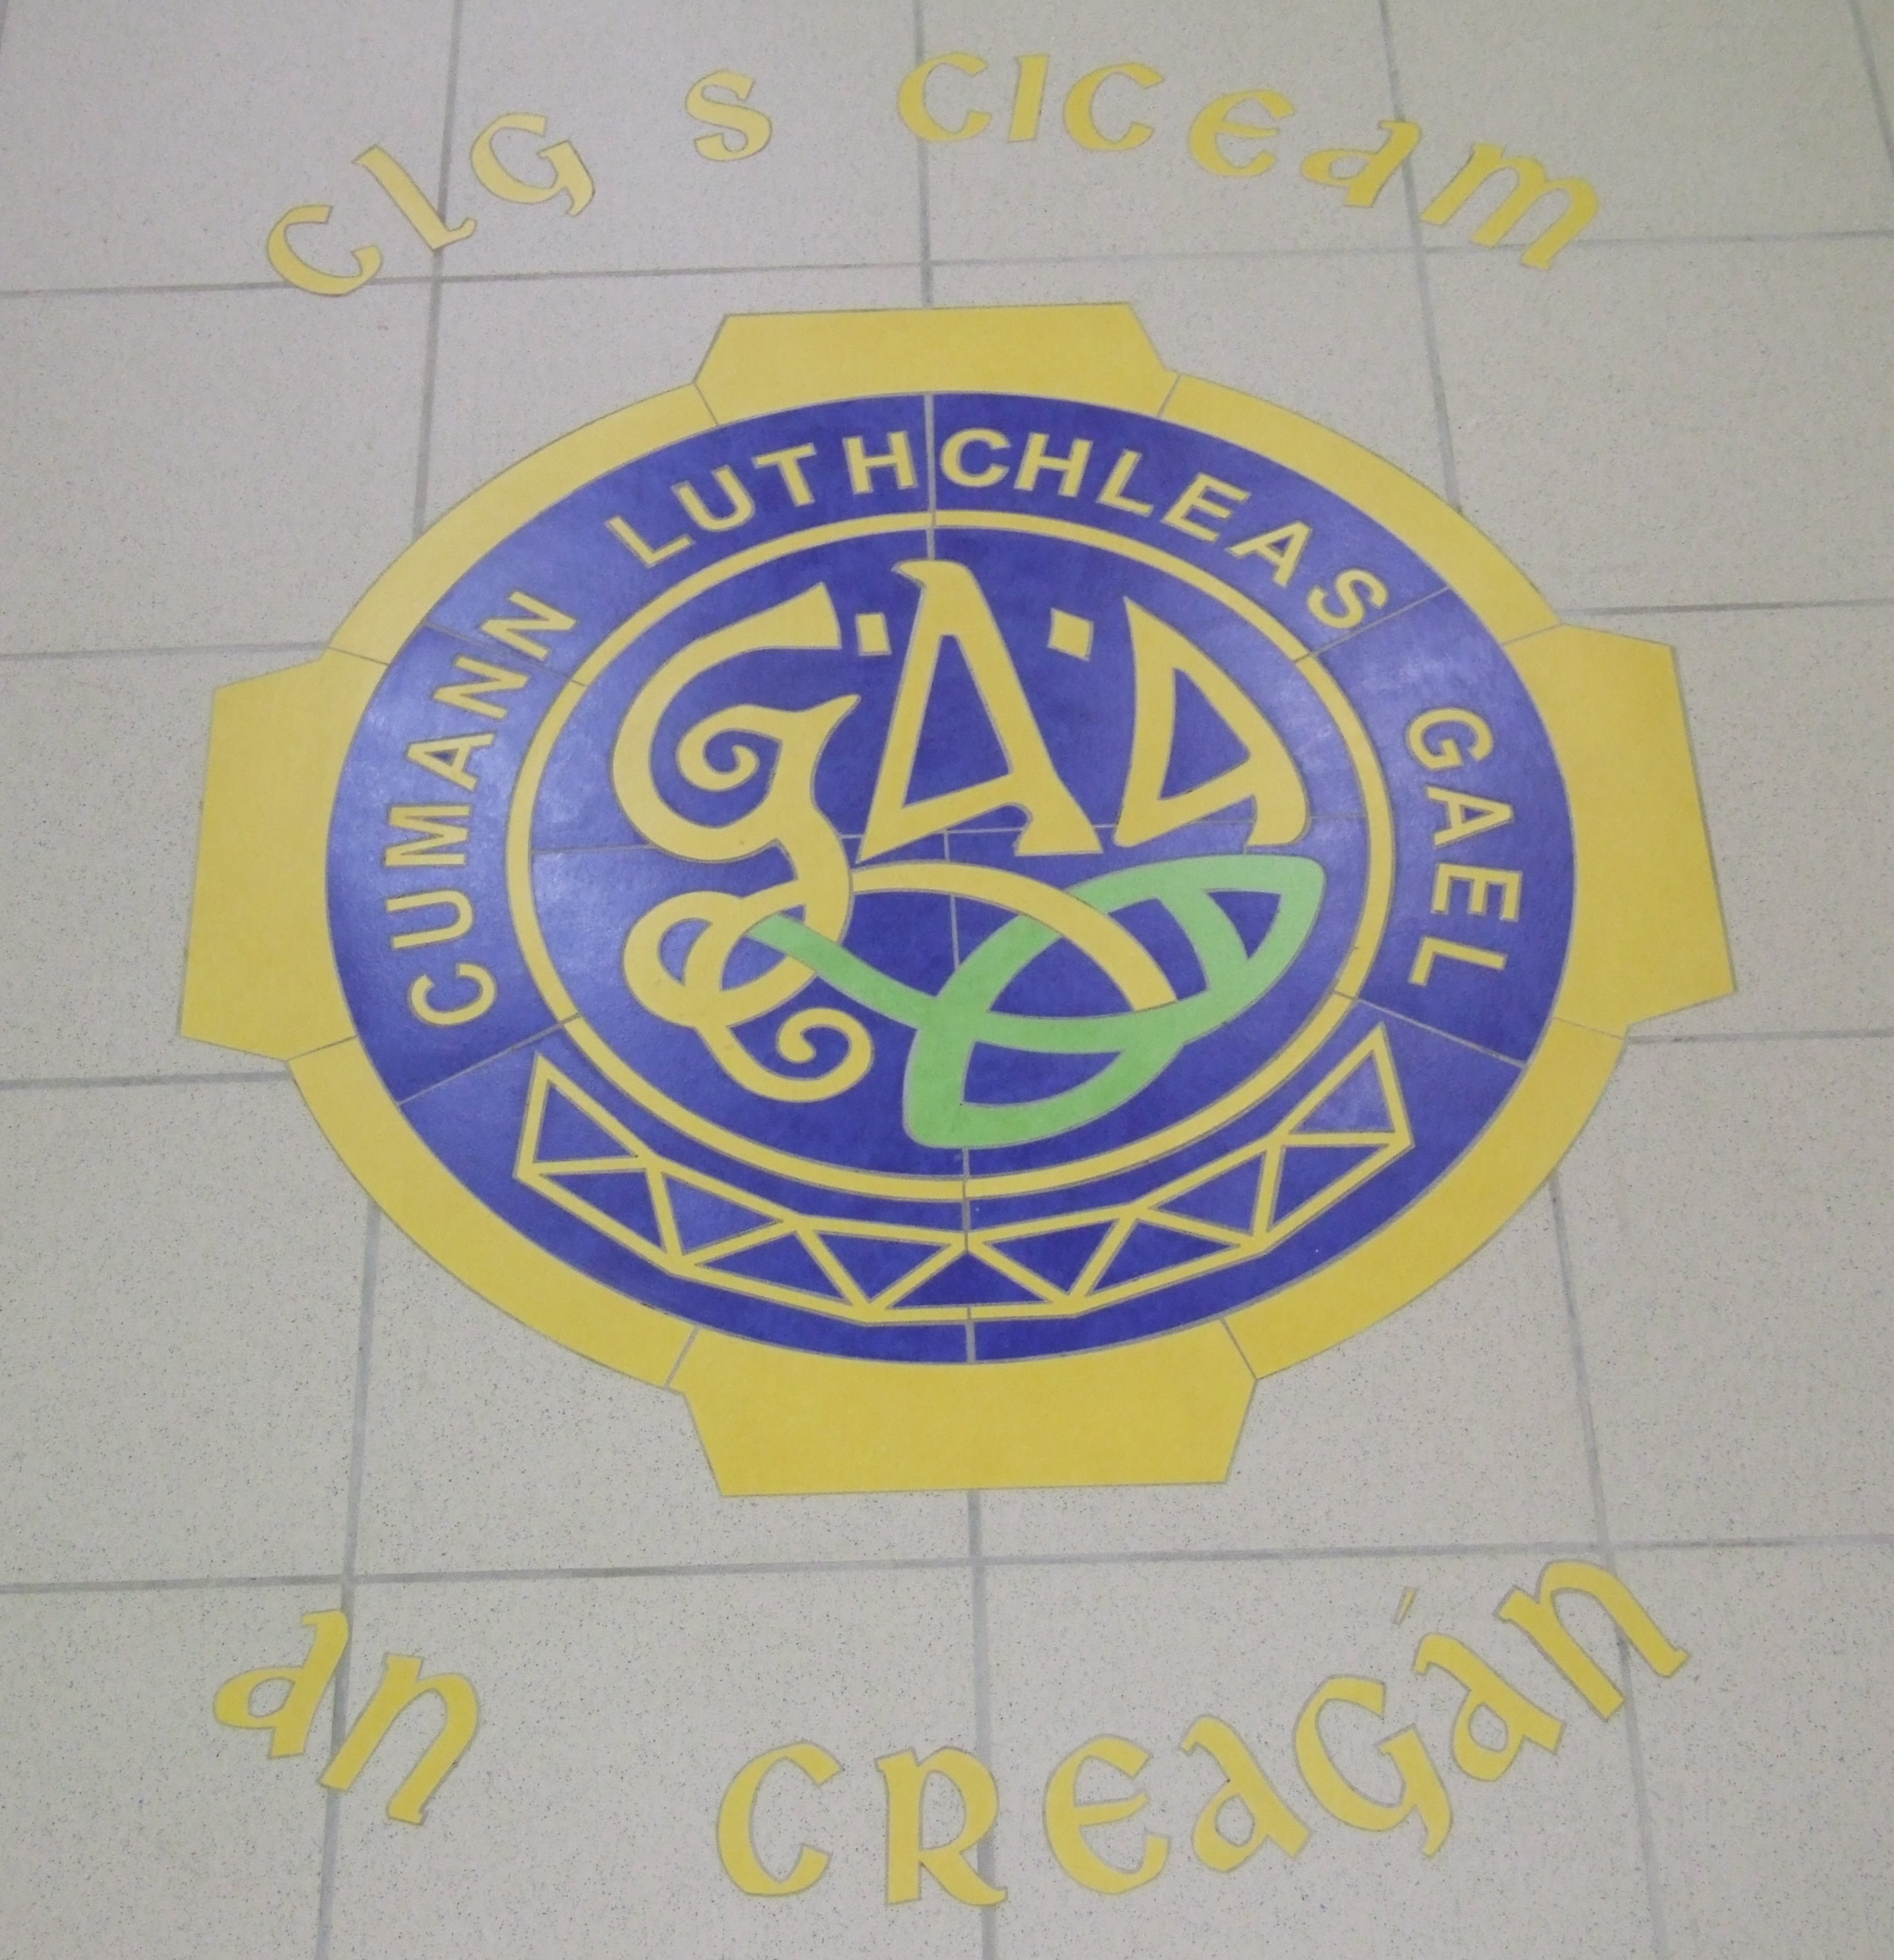

The Match of the Century!!
Together side by side for at least tonight - signed Tyrone/Kerry shirts mounted with the programme - the final to remember!!

Winter Wonderland!
Take your loved one to Prague for a long romantic break over Valentines weekend!!
Explore Wenceslas Square, stroll over the impressive Charles Bridge and taste the local Budvar.
Flying out on Thursday February 14th for 3 nights Bed and Breakfast staying in a 5* luxurious hotel!
Sponsored by The Robinson Group

We are the Champions!!!!
On Friday September 19th, our Minor Team brought home to Creggan our First Minor Antrim Championship!! This jersey has been signed by all the panel. A piece of Creggan history!!

Football Frenzy
2 tickets to watch Arsenel v Sunderland in the fantastic Emirates Sadium on Saturday 21 February 2009, overnight stay in a London hotel with flights.
Sponsored by Mr Dick McKeague

Charles Mc Auley Painting
The renowned artist from Cushendall, Co Antrim painted this piece of art.
There is a reserve of £3000 on this item.

For further details on the Auction Prizes please visit the Club website: www.kickhamscreggangac.com

